✦
THE BEHAVIOUR CODE
The Science of Reading People at Their Best
A Methodology White Paper
Signal Labs
v1 · 2026
“Who are you, at your best?”

EXECUTIVE SUMMARY

An instrument for the self at its best
The Behaviour Code is a five-minute, forced-choice instrument that answers one question: who are you, at your best? It is not a personality test. It does not diagnose what is wrong with you; it reveals the signal you send when you are most yourself, most effective, most recognizable.
This paper sets out the science beneath that claim. It begins where the question actually begins, in evolutionary biology and the way the human brain reads other people in a fraction of a second. It then describes the architecture of drives and emotions that organizes those readings, the established methods the instrument aggregates, and the standard to which it holds itself. That standard is the heart of the argument, so we state it plainly: we do not ask you to trust the Behaviour Code because a famous psychologist once drew a similar map. We ask you to judge it by whether it works, and we have built it to be measured.
PART I

We are pattern-reading animals
Long before anyone wrote a personality test, survival depended on reading other people fast. The human brain is built for it. Face detection is present within hours of birth; the ability to detect agents, to tell a who from a what, appears to be universal across cultures and deep in our evolutionary history. For a social primate, correctly categorizing the stranger approaching across the savannah, friend, rival, mate, threat, was not a parlour game. It was the difference between living and not.
Modern research shows how little information this takes. In the classic studies by Nalini Ambady and Robert Rosenthal, observers who watched two-to-ten-second silent clips of a teacher formed judgments that closely matched the judgments of students who had spent a full semester in the room. A few seconds of expressive behaviour carried most of the signal. Daniel Kahneman would later name the faculty responsible: System 1, the fast, intuitive, always-on mode of cognition that reaches a conclusion about a person before the deliberate mind has finished its first sentence.
The implication reorders everything. Identity is not a private interior fact waiting to be excavated by a long questionnaire. It is a signal, broadcast constantly, and read by others in the time it takes to glance up. So the useful question is not “what are your hidden traits.” It is: what pattern do you project, is it coherent, and is it the one you intend? Archetypes are simply the names our social brains already use for the recurring patterns we evolved to recognize. They are not mysticism. They are the compression format of human social cognition, the small set of legible figures we sort each other into in a tenth of a second.
This is why a result that cannot be grasped at a glance has already failed, no matter how accurate its underlying math. Legibility is not decoration. It is the whole point.
PART II

Drives and emotions: the architecture beneath the pattern
Beneath the twelve recognizable patterns sit three drives: Care, Create, and Conquer. These are not chosen for elegance. They converge with one of the most durable findings in the psychology of motivation. Through decades of empirical work, David McClelland identified three social motives that organize human striving: the need for affiliation, the need for achievement, and the need for power. They map cleanly onto our three drives, Care to affiliation, Create to achievement, Conquer to power. When two independent traditions, archetypal and motivational, arrive at the same three forces, that convergence is itself a form of evidence that the structure is describing something real.
Emotions are the layer that makes the drives visible. What a person feels, others read, through the face and voice that evolution tuned us to interpret. The drive organizes the motivation; the emotion broadcasts it; the archetype is the stable pattern that results when a person expresses the same drives the same way, again and again, until they become recognizable. From three drives the model opens to twelve archetypes, four per drive, and then to thirty-six avatars, three distinct faces of each archetype. The result is a vocabulary precise enough to place almost anyone, and small enough to carry in the head.
PART III

An aggregator, not an invention
The Behaviour Code does not claim to have discovered a new law of personality. There is no such law to discover, a point we return to below. What it claims is more defensible and more useful: it aggregates the most validated and effective methods in the field and collides them with a single purpose, revealing the self at its best. Each method below earns its place by what it contributes, and each is improved by the combination.
Method we aggregate | What it contributes | How the Behaviour Code improves on it
Jungian / Pearson archetypes | A vocabulary of recurring human character-patterns people recognize on sight | Held as hypothesis, not dogma; sharpened by a differentiation engine so each pattern is measurably distinct
Big Five / OCEAN | The field's benchmark for reliability and construct validity | We borrow the rigor and the benchmark, then translate trait math into a legible, shareable identity
McClelland's three motives | Empirical grounding for the three drives (Achievement, Affiliation, Power) | Reframed as Create, Care, Conquer and made the spine of both identity and work contribution
Forced-choice / MaxDiff (best-worst) | Defeats social-desirability bias and straight-lining that sink ordinary self-report | Used end to end (cards + bracket) so the result is earned through trade-offs, not claimed
Item Response Theory | Weighting items by how well they discriminate | The Trait-Value engine scores every trait's differentiation; high-signal items will count more
Thin-slicing / System 1 | The science of fast, accurate person-perception | Made the design constraint: the result must read at a glance, the way people actually judge
Self / Perceived / Lived (360-style) | Multiple perspectives reveal the gap between intent and impact | The Coherence Index turns that gap into one tracked number
Strengths-based (CliftonStrengths lineage) | Build from what is best, not what is broken | The whole instrument optimizes for the best self, not deficit detection
Narrative identity (McAdams) | Identity as a story one can act from | The reveal hands back a Code and a 'becoming', not a label

No single instrument on that list does all of this. The Big Five has rigor but hands a layperson thirty percentile scores, not a self they can act from. Archetype tools are legible but rarely measure whether their categories are actually distinct. Strengths assessments build from the best but stop at a list. The Behaviour Code's contribution is the synthesis: the rigor of the trait sciences, the legibility of archetypes, the honesty of forced choice, and the optimism of a strengths frame, aimed at one question.

From identity to contribution: the work arc
The same aggregation reaches past identity into how a person works. The three drives are not only motivational; they are the three phases of any piece of work. Care is where people and delivery live, Create is where ideas and craft are made, Conquer is where things are driven and decided. This is not ours alone. It is the arc that sits, under different names, beneath every serious model of workplace contribution.
Work-contribution model | Its roles | Its underlying arc
Working Genius (Lencioni) | Wonder, Invention, Discernment, Galvanizing, Enablement, Tenacity | Ideation → Activation → Implementation
Belbin Team Roles | Plant, Shaper, Implementer, Completer-Finisher, Coordinator, Teamworker (nine roles) | Thinking → Action → Social
The GC Index | Game Changer, Strategist, Play Maker, Implementer, Polisher | Impact across the business cycle

Read the right-hand column and the convergence is unmistakable: idea, then drive, then deliver. The Behaviour Code's three drives are that same arc, which is why the instrument that names who you are at your best also names where you add value on a team. Each archetype becomes a work mode, the Researcher, the Builder, the Closer, the Connector, and a team's mix of modes exposes both its coverage and its gaps. One difference is worth stating plainly: the established models lean toward idea and execution and under-weight the human, delivery half. Because Care is a full drive in our model, the People and Delivery phase is first-class, not an afterthought, which is precisely the half that decides whether good work ever lands.
PART IV

Answering the skeptic
Learning and development leaders are right to be skeptical, and they screen on the right things. The criteria that matter, codified in the Standards for Educational and Psychological Testing and in the Society for Industrial and Organizational Psychology's principles, are validity, reliability, and fairness. We take each in turn, including where we are still earning our evidence.
- Construct validity, the discriminant kind. A good instrument's categories must be distinct from one another, not overlapping restatements. Most archetype tools never test this. We do, continuously: a differentiation engine scores how uniquely each trait flags one archetype, and the library is built to maximize separation. A category that blurs into its neighbour is, by design, a category we fix.
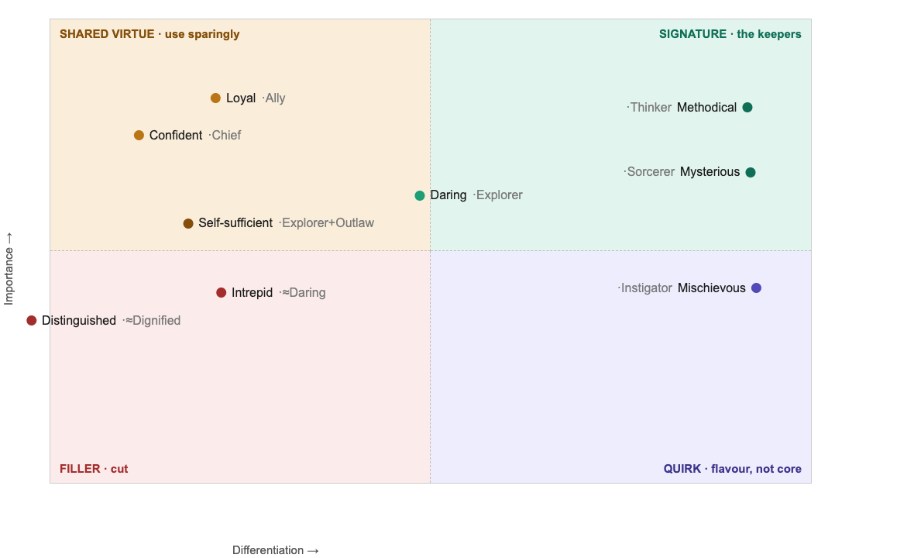
Figure 1. The Trait-Value matrix. Every trait is scored by Differentiation (horizontal) and Importance (vertical). Signature traits earn their place; near-synonyms and shared virtues fall to the cut zone, where Distinguished and Intrepid landed before we removed them.
- Reliability. The cardinal failure of the best-known type instrument is that between a third and three-quarters of people get a different result on retaking it within weeks. That instability comes largely from Likert self-report, which invites people to agree with everything. The Behaviour Code is forced-choice end to end: every answer is a trade-off, which suppresses the response styles that make results wobble. We design for a stable signal, and we measure that stability.
- The Barnum problem. The reason vague tests feel accurate is the Barnum effect: people accept flattering generalities as uniquely true of them. A statement that fits everyone is the enemy. Our differentiation standard is the direct antidote, because a trait that describes everyone scores zero on differentiation and is cut. We are, in a precise sense, engineered against horoscopes.
- Criterion validity. This is the evidence we are building now, in the open. Does a person's best-self Code predict outcomes that matter, recognition, performance, retention, fit? We do not claim predictive validity we have not earned. Instead we have instrumented the system to demonstrate it, through a calibration study and a resonance signal captured on every read. We would rather show our work than borrow a claim.
- Fairness. The three modes (individual, organization, brand) change only the framing of a question, never the scoring. The instrument takes no protected-class inputs, and forced choice reduces the advantage of impression management. Fairness is a property of the design, not an afterthought.

The honest foundation
There is a deeper point a serious buyer should hear, because it is the difference between a vendor and a partner. No personality taxonomy has a validated bedrock. Not the archetypes, which are a heritage rather than a proof. Not even the Big Five entirely, which is the most empirical of the family and is still a model, not a law of nature. It is, as the philosophers say, turtles all the way down. Every framework rests on assumptions that rest on further assumptions, with no final floor.
Most vendors hide this behind the name of a famous psychologist. We will not. If there is no bedrock to stand on, then the search for one is wasted motion, and the only honest criterion left is whether the instrument works. That is not a weaker standard than “scientifically validated.” It is a harder one. A citation can be borrowed; usefulness cannot be faked. We ask to be judged by results, and we have built the means to prove them.
PART V

The standard, and an instrument that learns
Utility is the whole criterion, and we hold it to four measurable axes. Resonance: does the result land as true, as 'that is me, at my best'? Differentiation: is it distinct, not a generality that fits anyone? Action: can a person actually do something with it? Adoption: does it spread? Differentiation we compute today. The other three are gathered from real use.
And the instrument learns. Every reading invites one more signal, is this you, at your best? That resonance data feeds back and re-tunes the weighting over time. A static test begins to decay the day it ships. A learning instrument compounds: it grows sharper at producing the true, distinct, useful read with every person who takes it. That is the most defensible thing we could build, and it is the honest answer to the only question that finally matters, how do you know it is getting better? Because we measure it, and it does.
CONCLUSION

The instrument we would trust ourselves
We set out to build the tool we would stake our own names on. It reads the signal human beings evolved to read, names it in a vocabulary people recognize on sight, aggregates the most validated methods in the field, and submits to the only test that cannot be faked: does it work, demonstrably, and does it get better.
That is the Behaviour Code. Not a personality test. An instrument for who you are, at your best.

APPENDIX A

The model
Three drives narrow to twelve archetypes, each opening into three distinct avatars. Your Code is your top three avatars, ordered, yielding 36 × 35 × 34 = 42,840 possible Codes, plus a named Shadow and an 'at your best' reveal.

Care · the drive to connect, support, and heal
Lover (Passionate, Magnetic, Devoted) · Dreamer (Optimistic, Idealistic, Sincere) · Ally (Reliable, Supportive, Genuine) · Nurturer (Compassionate, Patient, Steadfast)

Create · the drive to make, imagine, and express
Jester (Unconventional, Entertaining, Witty, Light-hearted) · Thinker (Objective, Insightful, Methodical, Wise) · Maker (Masterful, Original, Authentic, Enduring) · Wizard (Innovative, Ambitious, Visionary)

Conquer · the drive to lead, win, and rise
Explorer (Open-minded, Self-sufficient, Daring) · Outlaw (Individualistic, Non-conformist, Bold) · Chief (Confident, Noble, Just, Protective, Decisive) · Fighter (Duty, Discipline, Determination, Courage, Resilience)
Trait counts are variable by design: a trait earns its place by its measured value, or it is cut. The library is held stable as a working hypothesis and revised as evidence accumulates.
REFERENCES & FOUNDATIONS

Selected sources
Ambady, N., & Rosenthal, R. (1992). Thin slices of expressive behavior as predictors of interpersonal consequences: a meta-analysis. Psychological Bulletin, 111(2), 256-274.
Ambady, N., & Rosenthal, R. (1993). Half a minute: predicting teacher evaluations from thin slices of nonverbal behavior and physical attractiveness. Journal of Personality and Social Psychology, 64(3), 431-441.
Kahneman, D. (2011). Thinking, Fast and Slow. New York: Farrar, Straus and Giroux.
McClelland, D. C. (1961). The Achieving Society. Princeton, NJ: Van Nostrand; and Human Motivation (1987). Cambridge University Press.
Costa, P. T., & McCrae, R. R. (1992). Revised NEO Personality Inventory (NEO-PI-R) professional manual. Odessa, FL: Psychological Assessment Resources.
Forer, B. R. (1949). The fallacy of personal validation: a classroom demonstration of gullibility. Journal of Abnormal and Social Psychology, 44(1), 118-123. (The basis of the Barnum effect.)
AERA, APA, & NCME (2014). Standards for Educational and Psychological Testing. Washington, DC: American Educational Research Association.
Society for Industrial and Organizational Psychology (2018). Principles for the Validation and Use of Personnel Selection Procedures (5th ed.).
Louviere, J. J., Flynn, T. N., & Marley, A. A. J. (2015). Best-Worst Scaling: Theory, Methods and Applications. Cambridge University Press.
Pearson, C. S. (1991). Awakening the Heroes Within: Twelve Archetypes to Help Us Find Ourselves and Transform Our World. San Francisco: HarperSanFrancisco. (Building on C. G. Jung.)
McAdams, D. P. (1993). The Stories We Live By: Personal Myths and the Making of the Self. New York: William Morrow.
Accessible summaries consulted in preparation include peer-reviewed and reference material on thin-slicing (Columbia, Harvard Magazine), face and agent perception (Nature, Frontiers in Neuroscience), and comparative test reliability (Big Five vs. MBTI test-retest).

